SEE ELEC PREP

Induction motors: convert electrical energy to mechanical energy

Construction of 1ϕ Induction Motor

Two main parts:

* Stator (stationary part)
* Rotor (rotating part)

Stator:

* Laminated construction (stampings) to reduce iron losses.
* Slots on periphery for carrying stator winding or main winding.
* Uses silicon steel to minimize hysteresis loss.
* Wound for a certain number of poles which decides the synchronous speed (Ns)
* Ns=120f / P
* Motor runs slightly below synchronous speed.

Rotor:

* Always squirrel-cage type.
* Consists of solid bars (copper/aluminium), short-circuited by end rings.

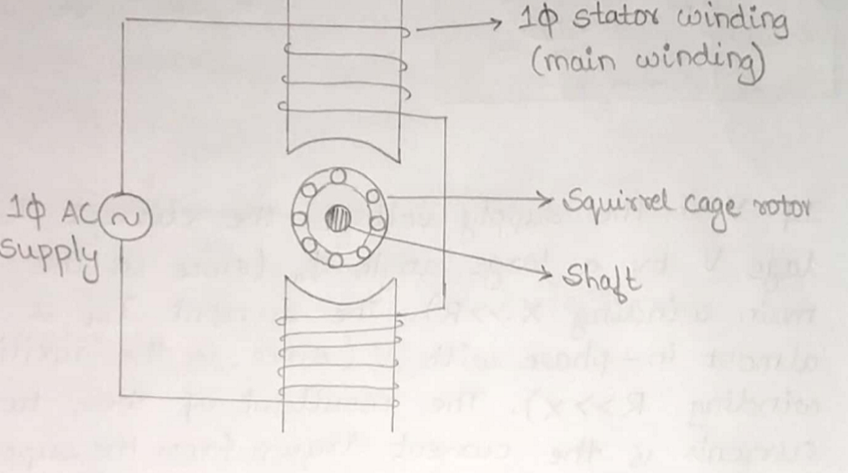

Split-Phase Induction Motor

* Converts single phase motor into two phase motor using:
  + Main winding (inductive in nature)
  + Auxiliary (starting) winding (high resistance compared to reactance, resistive in nature)

Currents:

* Im: Current in main winding → lags voltage V by large angle ϕm
* Ist: Current in auxiliary winding → almost in phase with V.
* The two currents produce a rotating magnetic field.
* A diagram of a line

  AI-generated content may be incorrect.

Centrifugal switch:

* Connected in series with auxiliary winding.
* Opens when motor reaches 75–80% synchronous speed, disconnecting auxiliary winding.

Capacitor-Start Induction Motor

Construction:

* Auxiliary winding in series with capacitor and centrifugal switch.
* The capacitor improves starting torque by making the phase difference between main and auxiliary currents larger.

Operation:

* Im lags voltage V by ϕm (main winding inductive).
* Ist leads V by ϕst (capacitor effect).
* Result: Larger starting torque, smaller current at start compared to split-phase motor.

Switch:

* Disconnects auxiliary winding at 75–80% synchronous speed.

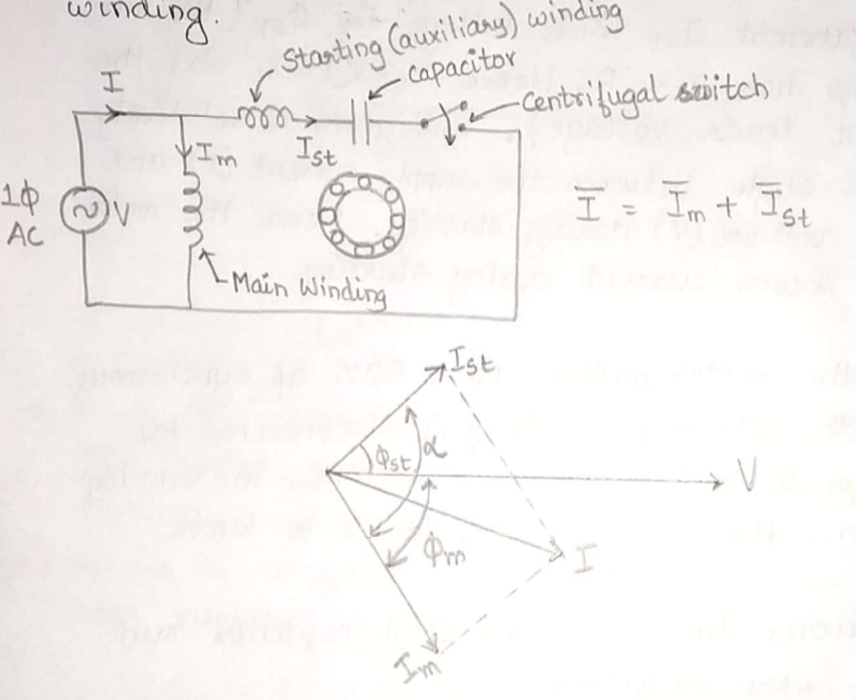

Capacitor-Start Capacitor-Run Motor

* No centrifugal switch → Capacitor always in circuit.
* Improves power factor during starting and running.
* Capacitor chosen as compromise between good start and good run performance.

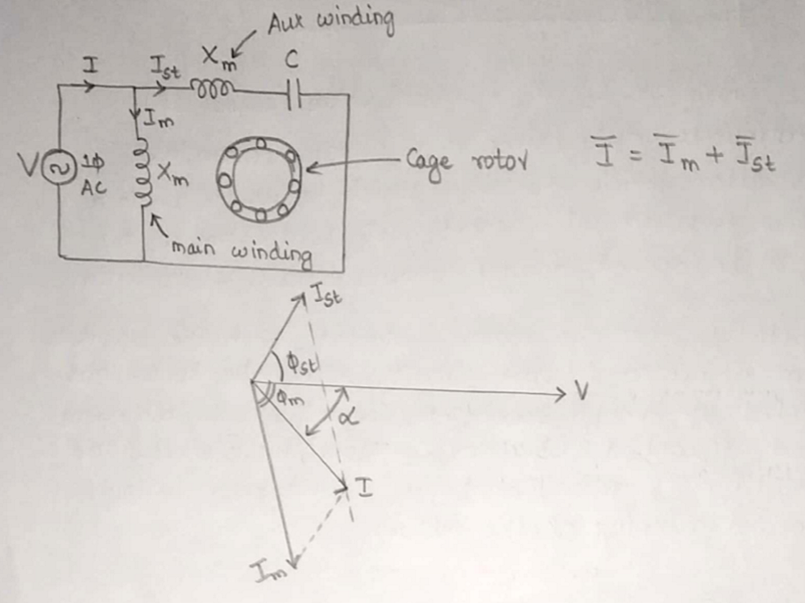

Two-Capacitor Motor (Capacitor Start, Capacitor Run with Two Capacitors)

* C1: Small, continuous-duty capacitor (few μF).
* C2: Large, short-duty capacitor (50–hundreds μF) for starting.
* At start: Both capacitors connected.
* After start: Centrifugal switch opens, disconnects C2, leaving only C1 in circuit.

**Applications Table**

| * **Motor Type** | * **Characteristic** | * **Rating** | * **Applications** |
| --- | --- | --- | --- |
| * Split-phase | * Moderate starting torque | * 1/20 HP – 1/2 HP | * Washing machines, blowers, centrifugal pumps, refrigerators, grinders |
| * Capacitor-start | * High starting torque | * 1/8 HP – 5 HP | * Compressors, large fans, blowers, portable hoists |
| * Capacitor-start capacitor-run | * Good power factor, high starting torque | * 1/8 HP – 5 HP | * Compressors, conveyor pumps |

Three-Phase Induction Motors

* Advantages
* Rugged, simple, and almost unbreakable construction.
* Low cost and highly reliable.
* High efficiency.
* Works with reasonably good power factor at rated load.
* Low maintenance requirements.
* Self-starting (small motors don’t require starters; large ones have simple arrangements).
* ________________________________________
* Disadvantages
* Essentially constant speed — speed variation is difficult.
* Speed drops slightly with increased load.
* Lower starting torque compared to some other motors.

Construction

* Two main parts:
  + Stator (stationary part)
  + Rotor (rotating part)

Stator

* Hollow cylindrical core made from high-grade, low loss silicon steel laminations (~0.4 mm thick) to reduce eddy current losses.
* Laminations slotted on the inner periphery to hold conductors.
* Conductors are placed in stator slots and insulated.
* Slots may hold one or more conductors; connected in star or delta.
* When supplied with 3-phase power, a constant magnitude rotating magnetic field is produced.
* Number of poles affects speed:
* Ns=120f/ P
* More poles → lower speed.
* Radial ducts provided for cooling.
* A diagram of a mechanical scheme

  AI-generated content may be incorrect.
* Slot types:
  + Open slots (for large motors; easy coil insertion)
  + Semi-closed slots (for small motors; better conductor retention)
* A diagram of electrical wiring

  AI-generated content may be incorrect.

Rotor

* Rotating part, mounted on a shaft to drive mechanical loads.
* Placed inside the stator; laminated core of cast iron or silicon steel.
* Cylindrical with slots on the periphery for rotor conductors.
* Two types:
  + Squirrel cage rotor
  + Slip ring (wound rotor)

Squirrel Cage Rotor

* Usage: Found in ~90% of induction motors.

Construction:

* Cylindrical laminated core with parallel slots.
* Each slot contains a solid uninsulated copper/aluminium bar (rotor conductor).
* Bars are short-circuited at both ends by copper end rings (welded or brazed).
* No slip rings or brushes.
* Slots are slightly skewed (not parallel to the shaft) to:
  + Reduce magnetic hum/noise.
  + Avoid magnetic locking between stator and rotor teeth.
* A drawing of a cylinder

  AI-generated content may be incorrect.

Characteristics:

* Simple, robust, low maintenance.
* Low rotor resistance → high efficiency.
* Moderate starting torque (not controllable)
* External resistance cannot be added → speed control not possible.

Slip Ring (Wound) Rotor

Construction:

* Laminated cylindrical core with uniform slots on the outer periphery.
* Slots contain 3-phase rotor winding (star or delta connected).
* The insulated winding are wound on top of the rotor like stator
* Winding ends are connected to three slip rings mounted on the shaft.\
* The slip rings require external resistance to have high starting torque, low initial current and improved power factor.
* Carbon brushes rest on slip rings for external connection.
* A diagram of a motor frame

  AI-generated content may be incorrect.

Operation:

* External resistances can be connected through slip rings → used as starters for high starting torque, low initial current and improved power factor.
* During running, slip rings are shorted (via metallic collar) and brushes lifted to reduce wear.

Characteristics:

* Allows high starting torque and speed control by varying rotor resistance.
* More complex and requires regular maintenance.
* Higher rotor copper losses → slightly lower efficiency than squirrel cage rotor.

**Comparison Table**

| **Feature** | **Squirrel Cage Rotor** | **Slip Ring Rotor** |
| --- | --- | --- |
| **Rotor Conductors** | Solid copper/aluminium bars, shorted by end rings | Wound conductors in star/delta connection |
| **Construction** | Simple | Complex |
| **External Resistance** | Cannot be added | Can be added via slip rings & brushes |
| **Slip Rings/Brushes** | Absent | Present |
| **Starting Torque** | Moderate, not controllable | High, controllable |
| **Poles Matching** | Automatic | Rotor poles ust match stator poles exactly |
| **Efficiency** | Higher (low rotor copper loss) | Lower (higher rotor copper loss) |
| **Maintenance** | Low, robust | High, delicate |
| **Speed Control** | Not possible via rotor resistance | Possible via rotor resistance |
|  |  |  |

Principle of RMF (rotating magnetic field)

* In a three-phase stator winding, the coils are physically spaced 120° apart.
* When connected to a balanced 3-phase AC supply:
  + The three currents are equal in magnitude but 120° out of phase in time.
  + Each current produces its own sinusoidal flux.
  + The three fluxes combine vectorially to give a resultant flux that is:
    - Constant in magnitude = 1.5 Φₘ
    - (Φₘ = max flux due to any one phase)
    - Rotating in space at a constant speed.

Equations for Phase Fluxes

* If phase sequence is R-Y-B:
* A white background with black lines and symbols

  AI-generated content may be incorrect.

Waveforms

* Each phase flux is sinusoidal and separated by 120° in time.
* Phasor diagram at any instant shows three vectors equally spaced (120° apart).
* A graph of a mathematical equation

  AI-generated content may be incorrect.

Conclusions

* Resultant flux amplitude is constant (1.5 Φₘ).
* Flux rotates smoothly in space → produces RMF.
* RMF speed = Synchronous Speed:
* Ns= 120f /P

Direction of RMF

* Depends on phase sequence of supply.
* Reverse RMF by interchanging any two supply lines.
* This also reverses motor rotation direction.

Working Principle

* Induction motors work on the principle of electromagnetic induction.
* When a 3-phase AC supply is given to the 3-phase stator winding, it produces a Rotating Magnetic Field (RMF) of constant magnitude.
* The speed of the RMF (also called synchronous speed) is given by:
* Ns= 120f / P
* Assume the RMF rotating clockwise inside the stator.
* At the instant we start the motor, the rotor is stationary.
* This means there is relative motion between the RMF (rotating field) and the rotor conductors (stationary conductors).
* Because of this relative motion, the magnetic field cuts the rotor conductors.
* According to Faraday’s law, this changing flux linkage induces an EMF in the rotor conductors.
* This EMF is called rotor induced EMF.
* Since the rotor forms a closed circuit, current flows through its conductors.
* Any current-carrying conductor produces its own magnetic field (flux).
* Therefore, the rotor current creates rotor flux.
* The magnitude of this flux depends on rotor current, and the direction is found using the right hand thumb rule.
* In this case, the rotor flux direction is also clockwise (same as RMF).
* A diagram of a rotor

  AI-generated content may be incorrect.
* Now, we have two fluxes:
  + RMF flux (from stator)
  + Rotor flux (from rotor currents)
* On one side of the rotor, both fluxes are in the same direction → they add up → high flux area.
* On the other side, they are in opposite directions → they cancel each other → low flux area.
* Due to the flux density difference, the high flux density area pushes the rotor toward the low flux density area.
* A diagram of a mechanical system

  AI-generated content may be incorrect.
* This produces a mechanical force on the rotor conductors.
* All rotor conductors experience this force in the same direction as the RMF.
* Hence, the rotor starts rotating in the same direction as RMF.

Lenz’s Law Explanation

* The induced current in the rotor flows in such a way as to oppose the cause producing it.
* The cause is the relative motion between the RMF and the rotor conductors.
* To oppose this relative motion, the rotor tries to catch up with the RMF by rotating in the same direction.
* Let:
* Ns = speed of RMF (rpm) → synchronous speed
* N = rotor speed (rpm)
* Relative speed between RMF & rotor = Ns−N

Question: Can N=Ns?

* If the rotor catches up with RMF speed, the relative motion becomes zero → no induced EMF, no rotor current, no rotor flux, and hence no torque → the motor would stop.
* In reality, due to inertia, the rotor can never catch up completely.
* Therefore:
* N<Ns
* Since induction motors do not run at synchronous speed, they are called asynchronous motors.

What is Slip?

* When an induction motor runs, the rotor speed N is always less than the synchronous speed Ns (speed of the RMF).
* The difference between Ns and N is called the slip speed:
* Slip speed = Ns−N
* Slip speed determines:
  + The magnitude of induced EMF in the rotor
  + The rotor current
  + The torque produced by the motor
* Without slip, there would be no relative motion between RMF and rotor → no EMF → no torque.
* Slip is usually expressed as a fraction of synchronous speed: s = (Ns−N) / Ns
* Unit: None (ratio of two speeds)
* From slip, rotor speed can also be calculated: N = Ns​(1−s)
* When motor is at rest, N=0 🡪 s = 1 (maximum slip 100%)
* If s=0, N = Ns (but in induction motors, N can **never** equal Ns)
* Thus, 0 < s <= 1
* As load increases:
* Rotor slows down slightly
* N decreases → Ns−N increases → slip increases

Effects of Slip on Motor Parameters

Effect on Rotor Frequency

* At start (N=0,s=1), rotor EMF frequency = supply frequency.
* At running condition: fr=sf
* This means rotor frequency is proportional to slip.

Effect on Magnitude of Rotor EMF

* At standstill: Rotor EMF per phase =E2 (maximum value)
* At running: E2r∝(Ns−N)
* Since s = (Ns−N) / Ns
* E2r=sE2
* So rotor EMF is slip times the standstill EMF.

Effect on Torque

* Torque T∝I2r (rotor current)
* Rotor current I2r∝E2r
* Therefore:
* T∝(Ns−N) 🡪 T∝s
* So, torque increases with slip (up to a certain point before saturation).

| **Condition** | **Slip ss** | **Rotor Frequency fr** | **Rotor EMF Magnitude** | **Torque** |
| --- | --- | --- | --- | --- |
| Standstill | 1 (100%) | f (supply freq) | E (max) | Max starting torque |
| Running | 0.01–0.05 (full-load) | Very small | sE2 | Load torque |
| Synchronous speed | 0 | 0 | 0 | 0 |

Applications of Induction Motors

* Squirrel-cage type motors
  + Moderate starting torque, constant speed.
  + Preferred for: fans, blowers, water pumps, grinders, lathes, drilling machines, printing machines, etc.
* Slip-ring induction motors
  + High starting torque (up to maximum torque).
  + Preferred for: lifts, hoists, elevators, cranes, compressors, etc.

Necessity of a Starter

* Induction motors are self-starting due to rotating magnetic field, but large motors require a starter to manage high inrush currents at startup.
* At start: motor speed = 0, slip = 1 → rotor induced EMF is very large → high rotor current.
* Effects of high starting current:
  + Possible damage to motor windings.
  + Large voltage drop affecting other devices on the same line.
* Starter’s role:
  + Limits starting current by reducing supply voltage during startup.
  + Once motor accelerates, full rated voltage is applied.
  + Provides protection against:
    - Overloading
    - Low voltage
    - Single-phasing (loss of one supply phase)

Thevinien

A bilateral network consisting of multiple voltage, current and resistors can be simplified to one voltage and resistor connected in series.

KCL

The incoming currents at a junction point is equal to the outgoing currents

KVL

The sum of all voltages in a circuit must be equal to the applied voltage.

Or

The algebraic sum of the changes in potential encountered in a loop must be equal to zero.

* Max power theorem: in a DC network, max power is transferred to the load when R(load) = R(thevenin)
* Impedance triangle: it is a triangle used to calculate the impedance, phase angle, pf and whether the voltage is leading or lagging from current.
* Since transformers are connected to const freq, const voltage supply, both f and Bm are const. thus core/iron losses are same at all loads.
* Transformers have two types of losses – iron and Cu. Cu loss is dependent on i(Rms) and iron loss is dependent on mag of voltage. Transformers losses are dependent on volt ampere and not on the phase angle b/w voltage and current. Thus rated in VA not kVA
* Transformer works on principle of mutual induction so current in the coil has to change uniformly. If dc supply is given, current will be const and transformer will not work. There can be saturation of the core due to which transformer draws large current from supply when connected to dc.

1 phase IM

* Construction

1. Stator windings in slots cut around the inner periphery.
2. Stator conductors have low resistance (starting winding)
3. Winding having high resistance are embedded deep inside the stator slots to have considerable inductance
4. Rotor is of squirrel cage type consisting of sold bars circuited at end rings.
5. To convert a single phase motor to a 2 phase motor, auxiliary windings are placed in the upper layers of the stator slots.
6. The auxiliary winding has a centrifugal switch in series with it.
7. The function of the switch is to cut off the starting winding when the rotor has accelerated to about 75% of the rated speed.
8. In capacitor start motors, an electrolyte capacitor of suitable capacitance value is also incorporated in the starting winding circuit.

* Working

1. Consider a 1 phase IM whose rotor is at rest.
2. Let a single phase ac source be connected to the stator winding (there is no starting winding)
3. The stator is wound for 2 poles.
4. When the power is on, ac flows through the stator windings and alternating flux is set up.
5. This flux crosses the air gap and links with the rotor conductors.
6. This induces emf in rotor conductors by emi.
7. Since rotor forms a closed circuit, currents are induced in the rotor bars.
8. The rotor induced currents interact with the stator flux to produce a torque.
9. All the rotor conductors in upper half come under stator N pole and the rotor conductors in lower half come under stator S pole.
10. Thus the upper half of the rotor is subjected to torque which tends to rotate in one direction and the lower half of the rotor is acted upon by an equal torque which tends to rotate in the opposite direction.
11. Two equal and opposite torques cancel out resulting in net zero torque.
12. thus rotor remains stationary.
13. This implies a single phase motor fails to develop a starting torque.
14. The rotor is in motion in any direction when the supply for stator is turned on as the rotor develops torque in that direction.

* 3 phase induction motor

1. Principle: based on emi
2. When the 3 phase winding is energized with a 3 phase supply, a rmf is set up with a synchronous speed Ns = 120f / P
3. This rmf crosses the air gap and links with the rotor conductors which are stationary.
4. An emf gets induced due to the relative speed b/w the rmf and stationary rotor.
5. Since rotor is short circuited, current starts flowing through the rotor conductors.
6. The current carrying conductors are placed in the magnetic field produced by the stator resulting in a mechanical force that acts on the rotor conductors.
7. The sum of the mechanical forces produces a torque which rotates the rotor in the same direction as the rmf of the stator.
8. Acc to lenz law the dirn of the rotor currents is such that they oppose the cause producing them.
9. To reduce the relative speed, the rotor is urged to follow the stator field.

* Motoring mode:
* ac supply is given to stator winding and the motor always rotates below the synchronous speed (Ns)
* IM torque varies from 0 to full load as the slip varies from 0 to 1
* s= 0 at no load and s=1 at standstill
* torque directly proportional to slip
* Generating mode:
* stator winding is given 3 phase supply and IM motor runs above the Ns which is driven by the prime mover.
* Torque and slip are negative and thus the motor receives mechanical energy and generates electrical energy
* IM is not used as a generator because it needs reactive power for its operation.
* This reactive power must be supplied from outside and if it runs below the Ns, it ends up consuming ee instead of giving ee.
* Breaking mode:
* two leads/polarity of supply voltage is changed so that the motor starts rotating in reverse dirn and comes to a stop.
* This method of breaking is called plugging and is used when the motor is to be stopped in a short period of time.
* KE of the revolving load and the motor receiving power from the stator is dissipated as heat.
* Due to this enormous amount of heat energy, the stator is disconnected from the supply before motor enters the breaking mode.
* If the load which motor drives accelerates the motor in the same dirn as the motor is rotating, the speed of motor (N) > Ns.
* This acts as an induction generator which supplies ee to the mains slowing down the motor to eventually stop.
* This method of breaking is called dynamic/regenerative breaking

1. Electricity is generated from generating stations (use charcoal, natural gas, water) by huge generators.
2. Current is sent to transformers where voltage is stepped up and pushes the power for long distance.
3. Electrical charge is sent through high voltage transmission lines that stretch across the country.
4. Once it reaches the substations voltage is lowered so that it can be sent to small power lines.
5. It travels through distribution lines to your neighbourhood small transformers which reduces the voltage for safe usage at home.
6. This connects to your house and passes through the meter.
7. Electricity goes to the service panel in the basement where fuse or mcb protects the wires in the houses from being overloaded.
8. Electricity travels through the wires inside the walls to the outlets and switches all over the house.

Fuse

Adv: Fast acting, highly reliable and relatively cheaper

Disadv: requires replacement and high temp affects other devices.

MCB:

* There are two arrangements of mcb which includes thermal effect of overcurrent and electromagenetic effect of overcurrent.
* The thermal operation is achieved by a bimetallic strip.
* When there is continuous over current flowing through the mcb, the bimetallic strip is heated and deflects by bending.
* This deflections of the strip releases the mechanical latch which is attached to the operating mechanism which inturn opens the mcb contacts.
* During short circuit condition, there is a sudden rise in current, which causes the electromechanical displacement of pluger associated with tripping coil or solenoid of mcb.
* This plunger strikes the trip lever which releases the latch mechanism which inturn break the mcb contacts.

Slip

* The ratio of the difference between the rotating stator flux and the speed of the rotor to the speed of the rotating stator flux.

Rms: represents the effective value of a fluctuating signal

Avg: arithmetic mean of all its instantaneous values over a specified time period